SIMATS ENGINEERING
ASSESSMENT TOOL 1: Knowledge Representation Design Assessment
COURSE NAME: ARTIFICIAL INTELLIGENCE COURSE CODE: MLA01
AND EXPERT SYSTEMS
COURSE OUTCOME COVERED
CO3: Implement propositional and first-order logic using resolution, unification, and inference techniques for knowledge representation and reasoning.(BTL 3)
Assessment Tool Weightage: 40 %

Total Marks: 100 Time: 60 Mins
No. of Questions: 5
Annexure A
Knowledge Representation Design Assessment

Code of Conduct:
I Uppu Sye Kumar/192325121 (Name / Reg No) certify that this submission is my original work and that I have adhered to the guidelines specified for this assessment. I understand that any violation of academic integrity rules will result in disciplinary action.
Signature of the student: U.SyeKumar
Criterion | Weightage | Marks Obtained
1. Problem Analysis and Domain Understanding | 10%
2. Knowledge Engineering and Knowledge Base Design | 15%
3. Propositional Logic Representation | 10%
4. First-Order Logic Representation | 15%
5. Unification and Resolution | 15%
6. Forward and Backward Chaining | 15%
7. Inference and Reasoning Accuracy | 10%
8. System Architecture / Representation Diagram | 5%
9. Prototype Implementation and Results | 5%
Total | 100%

Signature of the Faculty Total Marks Awarded

ANSWER ANY ONE QUESTION

Smart Healthcare Diagnosis System
A hospital wants to develop an AI-based system that can identify possible illnesses from patient symptoms. The system contains facts such as:
- Ravi has fever.
- Ravi has cough.
- Ravi has body pain.
- Patients with fever and cough may have flu.
- Patients with flu and body pain may have viral infection.
- Patients with viral infection should be advised to rest.
Task:
- Represent the given knowledge using Propositional Logic.
- Convert the knowledge into First-Order Logic (FOL).
- Construct a knowledge base containing facts and rules.
- Demonstrate unification for at least two predicates.
- Use forward chaining to determine Ravi's condition.
- Use backward chaining to prove whether Ravi needs rest.
- Demonstrate resolution for one selected query.
- Explain the final inference produced by the system.

Intelligent Loan Approval System
A bank wants to develop an AI system to determine whether a customer is eligible for a loan. The knowledge base contains information about income, credit score, employment, existing loans, and repayment history.
For example:
- Arun has a stable job.
- Arun has a high credit score.
- Arun has sufficient income.
- Customers with stable employment and sufficient income are eligible for preliminary approval.
- Customers with high credit scores and good repayment history are considered low-risk.
- Low-risk customers with preliminary approval can be recommended for loan approval.
Task:
- Identify the entities, facts, predicates, and rules involved.
- Represent the knowledge using First-Order Logic.
- Build a knowledge base with at least 10 facts and 8 rules.
- Demonstrate unification and substitution.
- Apply forward chaining to determine whether Arun can be recommended for approval.
- Apply backward chaining for the query LoanApproved(Arun).
- Use resolution to prove or disprove one query.
- Discuss how the knowledge-engineering process helps maintain the loan rules.

Intelligent Vehicle Fault Diagnosis
An automobile service center wants to develop an expert system that identifies possible vehicle faults based on symptoms.
The system knows that:
- A vehicle has a dead battery if it does not start and the headlights are dim.
- A vehicle may have a fuel problem if the engine cranks but does not start.
- A vehicle may have an overheating problem if the temperature is high and coolant is low.
- A vehicle should be sent for immediate service if overheating is detected.
For a vehicle named Car101, the system receives:
- Car101 does not start.
- Car101 has dim headlights.
- Car101 has a high temperature.
Task:
- Design the knowledge representation for the vehicle diagnosis system.
- Represent at least five rules using FOL.
- Represent selected statements using Propositional Logic.
- Demonstrate unification using suitable predicates.
- Apply forward chaining to identify possible faults.
- Apply backward chaining for the query NeedsService(Car101).
- Demonstrate resolution for one diagnosis.
- Explain how inference is used to arrive at the final diagnosis.

Intelligent Student Academic Advising System
A university wants an AI-based academic advising system that recommends actions to students based on their academic performance.
The system contains rules such as:
- Students with attendance below 75% require attendance counseling.
- Students who fail two or more courses require academic counseling.
- Students with high attendance and good academic performance can be recommended for advanced courses.
- Students who have completed prerequisite courses can register for the corresponding advanced course.
Consider a student Priya who has:
- Attendance of 68%.
- Two failed courses.
- Completed the prerequisite for an advanced AI course.
Task:
- Identify the knowledge engineering requirements for the system.
- Represent the academic rules using FOL.
- Create a knowledge base containing facts and rules.
- Demonstrate unification using student and course predicates.
- Use forward chaining to identify recommendations for Priya.
- Use backward chaining to determine whether Priya requires academic counseling.
- Apply resolution to prove one selected recommendation.
- Explain the advantages and limitations of using a rule-based inference system for academic advising.

Cybersecurity Threat Detection System
An organization wants to develop an AI knowledge-based system to identify suspicious activities in its network.
The knowledge base contains rules such as:
- Multiple failed login attempts from the same user may indicate a brute-force attack.
- A login from an unusual location combined with multiple failed attempts indicates suspicious activity.
- Suspicious activity followed by unauthorized file access indicates a possible security breach.
- A possible security breach should generate a high-priority alert.
For user User101, the system observes:
- Five failed login attempts.
- Login from an unusual location.
- Unauthorized access to a confidential file.
Task:
- Design a knowledge representation model for the cybersecurity domain.
- Represent the knowledge using Propositional Logic and FOL.
- Construct at least 10 facts and 8 rules.
- Demonstrate unification and substitution.
- Apply forward chaining to determine whether a security alert should be generated.
- Apply backward chaining for the query HighPriorityAlert(User101).
- Use resolution to prove the existence of a possible security breach.
- Compare forward chaining and backward chaining for cybersecurity reasoning and justify which is more suitable.

INTELLIGENT LOAN APPROVAL SYSTEM

1. Introduction
An Intelligent Loan Approval System is a knowledge-based AI system that uses customer information and logical rules to determine whether a customer is suitable for loan approval. The system considers employment stability, income, credit score, repayment history, existing loans, debt level, and documentation. The system demonstrates First-Order Logic (FOL), unification, substitution, forward chaining, backward chaining, and resolution.

2. Entities, Facts, Predicates and Rules

2.1 Entities
The primary entity in this example is:
- Customer: Arun
The same predicates and rules can be applied to other customers such as Ravi, Priya, or Kumar.

2.2 Facts
- Arun has stable employment.
- Arun has a high credit score.
- Arun has sufficient income.
- Arun has good repayment history.
- Arun has an existing loan.
- Arun has no payment default.
- Arun has valid employment.
- Arun has acceptable debt level.
- Arun has submitted valid documents.
- Arun has passed basic eligibility verification.

2.3 Predicates
Predicate | Meaning
StableEmployment(x) | x has stable employment
HighCredit(x) | x has a high credit score
SufficientIncome(x) | x has sufficient income
GoodRepayment(x) | x has good repayment history
ExistingLoan(x) | x has an existing loan
NoDefault(x) | x has no repayment default
ValidEmployment(x) | x has valid employment
AcceptableDebt(x) | x has acceptable debt
ValidDocuments(x) | x has submitted valid documents
BasicEligible(x) | x satisfies basic eligibility
PreliminaryApproval(x) | x receives preliminary approval
LowRisk(x) | x is classified as low-risk
LoanRecommended(x) | loan is recommended for x
LoanApproved(x) | loan is approved for x

3. Knowledge Base
Knowledge Base = Facts + Rules

3.1 Ten Facts
F1: StableEmployment(Arun)
F2: HighCredit(Arun)
F3: SufficientIncome(Arun)
F4: GoodRepayment(Arun)
F5: ExistingLoan(Arun)
F6: NoDefault(Arun)
F7: ValidEmployment(Arun)
F8: AcceptableDebt(Arun)
F9: ValidDocuments(Arun)
F10: BasicEligible(Arun)

4. Eight Rules

Rule 1 – Preliminary approval
StableEmployment(x) ∧ SufficientIncome(x)
→ PreliminaryApproval(x)
A customer with stable employment and sufficient income receives preliminary approval.

Rule 2 – Low-risk customer
HighCredit(x) ∧ GoodRepayment(x)
→ LowRisk(x)
A customer with high credit and good repayment history is considered low-risk.

Rule 3 – Reliable customer
GoodRepayment(x) ∧ NoDefault(x)
→ ReliableCustomer(x)
A customer with good repayment history and no defaults is considered reliable.

Rule 4 – Debt verification
ExistingLoan(x) ∧ AcceptableDebt(x)
→ DebtAcceptable(x)
An existing loan is acceptable when the customer's overall debt is within the permitted limit.

Rule 5 – Employment verification
ValidEmployment(x) ∧ StableEmployment(x)
→ EmploymentVerified(x)
Employment is verified when it is valid and stable.

Rule 6 – Basic eligibility
ValidDocuments(x) ∧ EmploymentVerified(x)
→ BasicEligible(x)
Valid documents and verified employment establish basic eligibility.

Rule 7 – Loan recommendation
PreliminaryApproval(x) ∧ LowRisk(x)
→ LoanRecommended(x)
A low-risk customer with preliminary approval can be recommended for a loan.

Rule 8 – Final loan approval
LoanRecommended(x) ∧ DebtAcceptable(x) ∧ NoDefault(x)
→ LoanApproved(x)
A recommended customer can receive final approval when debt is acceptable and there are no defaults.

4.1 Complete Rule Set
R1: StableEmployment(x) ∧ SufficientIncome(x)
→ PreliminaryApproval(x)
R2: HighCredit(x) ∧ GoodRepayment(x)
→ LowRisk(x)
R3: GoodRepayment(x) ∧ NoDefault(x)
→ ReliableCustomer(x)
R4: ExistingLoan(x) ∧ AcceptableDebt(x)
→ DebtAcceptable(x)
R5: ValidEmployment(x) ∧ StableEmployment(x)
→ EmploymentVerified(x)
R6: ValidDocuments(x) ∧ EmploymentVerified(x)
→ BasicEligible(x)
R7: PreliminaryApproval(x) ∧ LowRisk(x)
→ LoanRecommended(x)
R8: LoanRecommended(x) ∧ DebtAcceptable(x) ∧ NoDefault(x)
→ LoanApproved(x)

5. Knowledge Representation Diagram
Figure 1: Facts, predicates and rules leading to the loan approval decision.
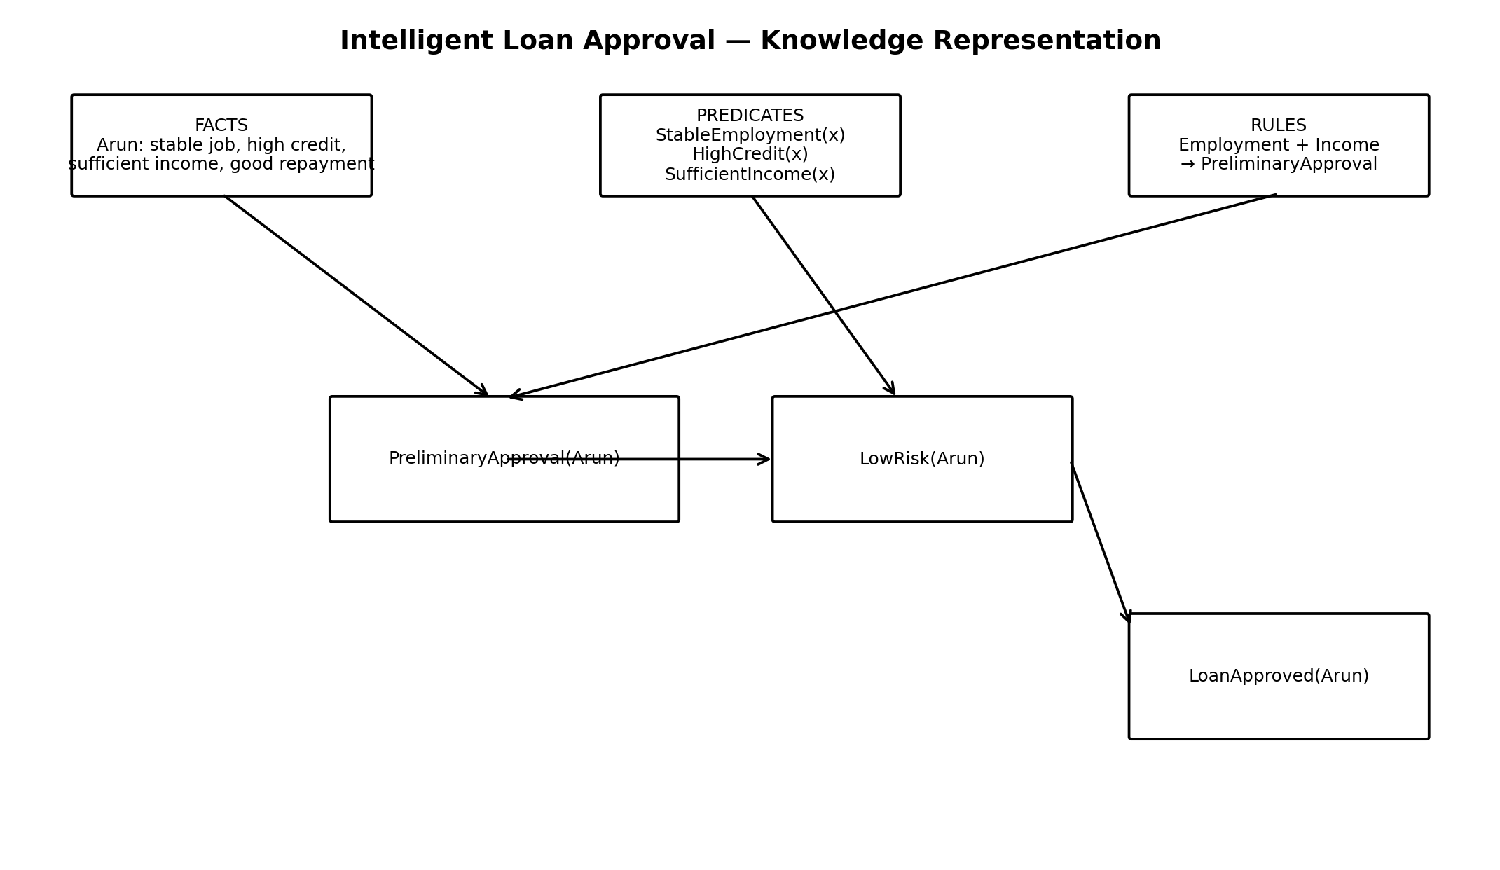

6. First-Order Logic Representation
The facts can be represented directly as ground predicates:
StableEmployment(Arun)
HighCredit(Arun)
SufficientIncome(Arun)
GoodRepayment(Arun)
ExistingLoan(Arun)
NoDefault(Arun)
ValidEmployment(Arun)
AcceptableDebt(Arun)
ValidDocuments(Arun)
BasicEligible(Arun)
Rules in First-Order Logic:
∀x [StableEmployment(x) ∧ SufficientIncome(x) → PreliminaryApproval(x)]
∀x [HighCredit(x) ∧ GoodRepayment(x) → LowRisk(x)]
∀x [GoodRepayment(x) ∧ NoDefault(x) → ReliableCustomer(x)]
∀x [ExistingLoan(x) ∧ AcceptableDebt(x) → DebtAcceptable(x)]
∀x [ValidEmployment(x) ∧ StableEmployment(x) → EmploymentVerified(x)]
∀x [ValidDocuments(x) ∧ EmploymentVerified(x) → BasicEligible(x)]
∀x [PreliminaryApproval(x) ∧ LowRisk(x) → LoanRecommended(x)]
∀x [LoanRecommended(x) ∧ DebtAcceptable(x) ∧ NoDefault(x) → LoanApproved(x)]
Here, ∀x means “for every customer x.”

7. Unification and Substitution

7.1 Unification
Unification is the process of finding substitutions that make two logical expressions identical.
StableEmployment(x)
StableEmployment(Arun)
Most General Unifier (MGU):
{x / Arun}
Therefore:
x = Arun

7.2 Substitution
StableEmployment(x) → StableEmployment(Arun)
SufficientIncome(x) → SufficientIncome(Arun)
R1 becomes:
StableEmployment(Arun) ∧ SufficientIncome(Arun)
→ PreliminaryApproval(Arun)
Since both conditions are known facts, PreliminaryApproval(Arun) is derived.
Another example:
HighCredit(x)
HighCredit(Arun)
MGU = {x / Arun}
After substitution:
HighCredit(Arun)

8. Forward Chaining
Forward chaining is a data-driven reasoning method. It starts with known facts and repeatedly applies rules to derive new facts until the desired conclusion is obtained.

8.1 Initial Facts
StableEmployment(Arun)
HighCredit(Arun)
SufficientIncome(Arun)
GoodRepayment(Arun)
ExistingLoan(Arun)
NoDefault(Arun)
ValidEmployment(Arun)
AcceptableDebt(Arun)
ValidDocuments(Arun)
BasicEligible(Arun)

Step 1 – Apply R1
StableEmployment(Arun) ∧ SufficientIncome(Arun)
→ PreliminaryApproval(Arun)

Step 2 – Apply R2
HighCredit(Arun) ∧ GoodRepayment(Arun)
→ LowRisk(Arun)

Step 3 – Apply R3
GoodRepayment(Arun) ∧ NoDefault(Arun)
→ ReliableCustomer(Arun)

Step 4 – Apply R4
ExistingLoan(Arun) ∧ AcceptableDebt(Arun)
→ DebtAcceptable(Arun)

Step 5 – Apply R5
ValidEmployment(Arun) ∧ StableEmployment(Arun)
→ EmploymentVerified(Arun)

Step 6 – Apply R6
ValidDocuments(Arun) ∧ EmploymentVerified(Arun)
→ BasicEligible(Arun)

Step 7 – Apply R7
PreliminaryApproval(Arun) ∧ LowRisk(Arun)
→ LoanRecommended(Arun)

Step 8 – Apply R8
LoanRecommended(Arun) ∧ DebtAcceptable(Arun) ∧ NoDefault(Arun)
→ LoanApproved(Arun)

8.2 Forward-Chaining Summary
Step | Rule Applied | New Fact
1 | R1 | PreliminaryApproval(Arun)
2 | R2 | LowRisk(Arun)
3 | R3 | ReliableCustomer(Arun)
4 | R4 | DebtAcceptable(Arun)
5 | R5 | EmploymentVerified(Arun)
6 | R6 | BasicEligible(Arun)
7 | R7 | LoanRecommended(Arun)
8 | R8 | LoanApproved(Arun)
Final forward-chaining result: LoanApproved(Arun) = TRUE.

9. Forward and Backward Chaining Diagram
Figure 2: Forward chaining from facts to approval and the corresponding backward reasoning path.
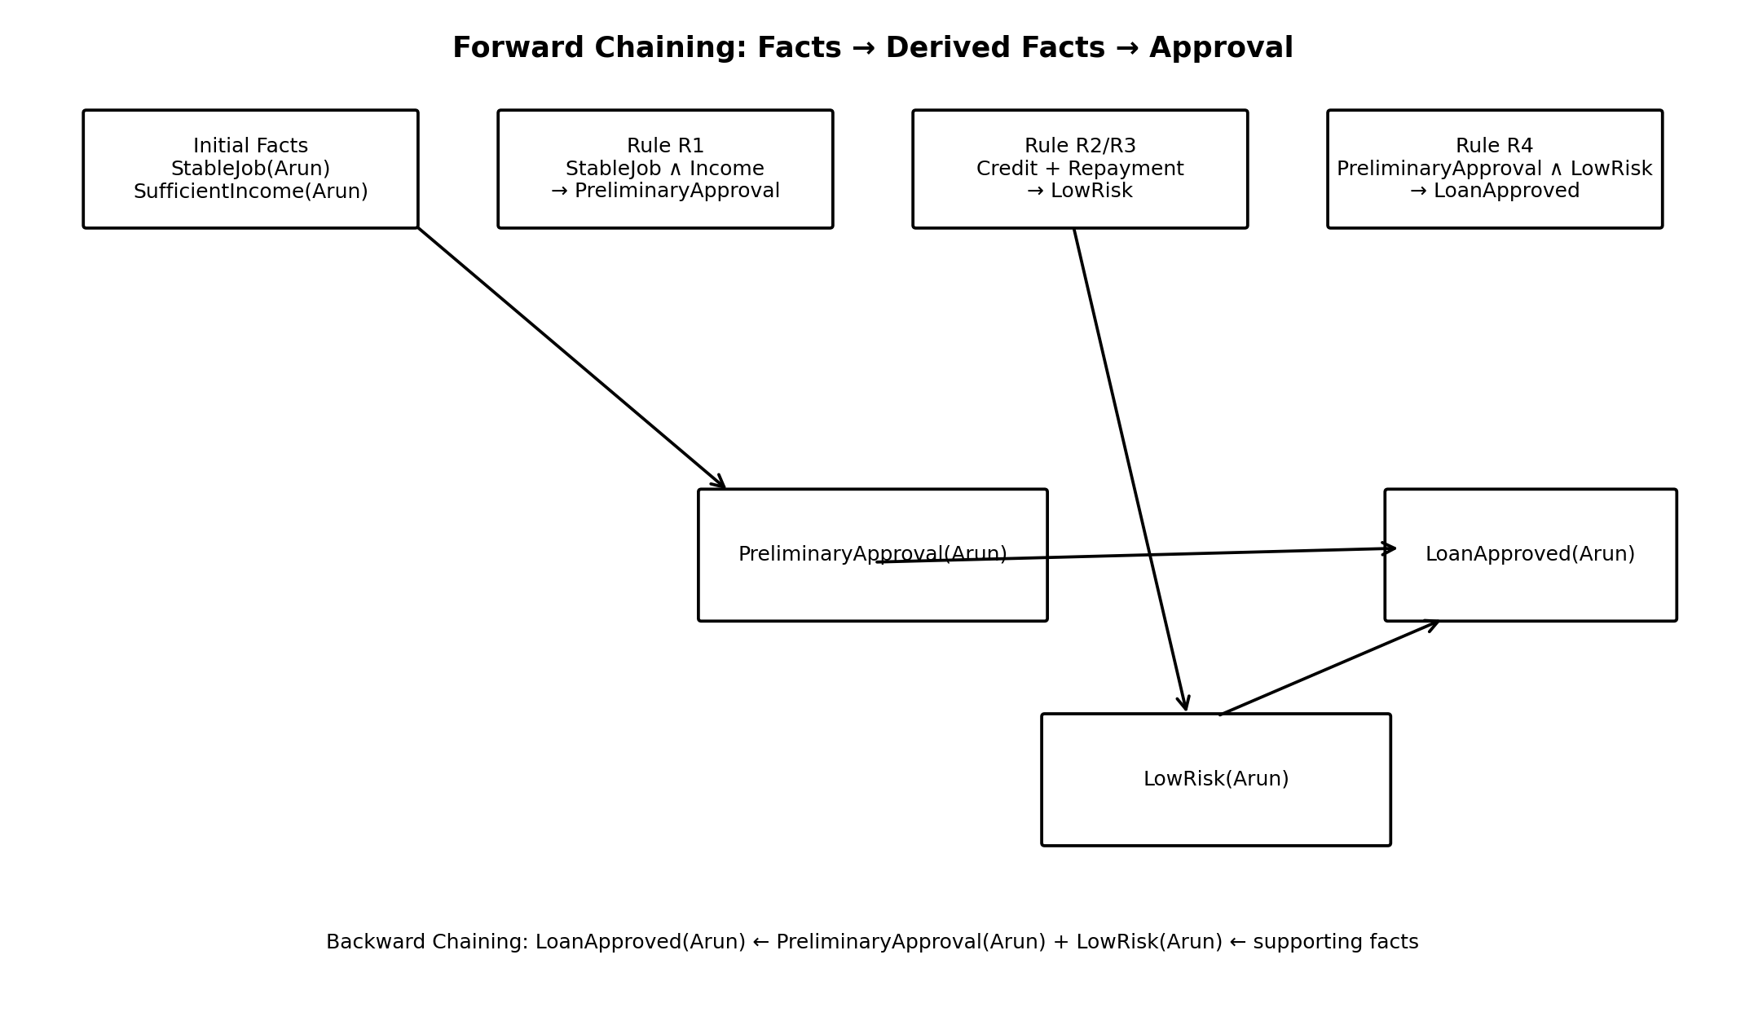

10. Backward Chaining
Backward chaining is goal-driven reasoning. It starts with the target query and works backward to determine which rules and facts are required to prove it.

10.1 Query
LoanApproved(Arun)

10.2 Goal Expansion
R8:
LoanRecommended(x) ∧ DebtAcceptable(x) ∧ NoDefault(x)
→ LoanApproved(x)
Substitute x = Arun:
LoanRecommended(Arun)
DebtAcceptable(Arun)
NoDefault(Arun)

10.3 Prove LoanRecommended(Arun)
R7:
PreliminaryApproval(x) ∧ LowRisk(x)
→ LoanRecommended(x)
Required:
PreliminaryApproval(Arun)
LowRisk(Arun)

10.4 Prove PreliminaryApproval(Arun)
R1:
StableEmployment(x) ∧ SufficientIncome(x)
→ PreliminaryApproval(x)
Known:
StableEmployment(Arun)
SufficientIncome(Arun)
Therefore:
PreliminaryApproval(Arun) = TRUE

10.5 Prove LowRisk(Arun)
R2:
HighCredit(x) ∧ GoodRepayment(x)
→ LowRisk(x)
Known:
HighCredit(Arun)
GoodRepayment(Arun)
Therefore:
LowRisk(Arun) = TRUE

10.6 Prove DebtAcceptable(Arun)
R4:
ExistingLoan(x) ∧ AcceptableDebt(x)
→ DebtAcceptable(x)
Known:
ExistingLoan(Arun)
AcceptableDebt(Arun)
Therefore:
DebtAcceptable(Arun) = TRUE

10.7 Prove NoDefault(Arun)
NoDefault(Arun) is a direct fact.
Therefore:
NoDefault(Arun) = TRUE
All subgoals are satisfied. Therefore, LoanApproved(Arun) is TRUE.

10.8 Backward-Chaining Tree
LoanApproved(Arun)
|
| R8
↓
LoanRecommended(Arun)
/ / ↓ ↓
Preliminary LowRisk
Approval
| |
R1 R2
/ \ / Stable Income Credit Repayment
Job
+ DebtAcceptable(Arun)
|
R4
/ Existing Acceptable
Loan Debt
+ NoDefault(Arun)
|
FACT

11. Resolution
Resolution is an inference technique that can prove a query by contradiction. To prove LoanApproved(Arun), we temporarily assume its negation and show that the knowledge base leads to a contradiction.

11.1 Convert a Rule to Clause Form
R1:
StableEmployment(x) ∧ SufficientIncome(x)
→ PreliminaryApproval(x)
Clause form:
¬StableEmployment(x) ∨ ¬SufficientIncome(x)
∨ PreliminaryApproval(x)

11.2 Resolution Steps
Facts:
StableEmployment(Arun)
SufficientIncome(Arun)
Resolve:
StableEmployment(Arun)
+
¬StableEmployment(Arun) ∨ ¬SufficientIncome(Arun)
∨ PreliminaryApproval(Arun)
Result:
¬SufficientIncome(Arun) ∨ PreliminaryApproval(Arun)
Resolve with:
SufficientIncome(Arun)
Result:
PreliminaryApproval(Arun)
Continue with R7:
¬PreliminaryApproval(x) ∨ ¬LowRisk(x) ∨ LoanRecommended(x)
Using:
PreliminaryApproval(Arun)
LowRisk(Arun)
Derive:
LoanRecommended(Arun)
Finally use R8:
¬LoanRecommended(x) ∨ ¬DebtAcceptable(x)
∨ ¬NoDefault(x) ∨ LoanApproved(x)
Using:
LoanRecommended(Arun)
DebtAcceptable(Arun)
NoDefault(Arun)
Derive:
LoanApproved(Arun)

11.3 Resolution by Contradiction
Query:
LoanApproved(Arun)
Negated query:
¬LoanApproved(Arun)
Knowledge base derives:
LoanApproved(Arun)
Therefore:
LoanApproved(Arun) ∧ ¬LoanApproved(Arun)
This is a contradiction.
Hence:
KB ⊨ LoanApproved(Arun)

12. Resolution Proof Diagram
Figure 3: Resolution proof by contradiction.
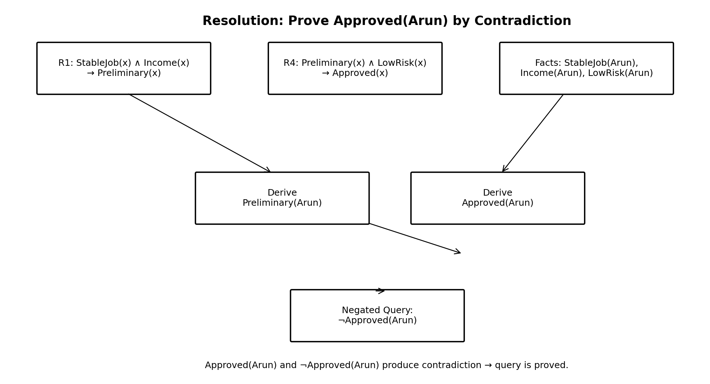

13. Complete Inference Flow
CUSTOMER: ARUN
|
┌─────────────┼─────────────┐
↓ ↓ ↓
Stable Job High Credit Good Repayment
| | |
↓ └──────┬──────┘
Sufficient Income ↓
| Low Risk
↓ |
Preliminary Approval |
| |
└──────────┬──────────┘
↓
Loan Recommended
|
┌──────────┴──────────┐
↓ ↓
Debt Acceptable No Default
| |
└──────────┬──────────┘
↓
LOAN APPROVED

14. Knowledge-Engineering Process
Knowledge engineering is the process of collecting, representing, organizing, validating, and maintaining knowledge so that an AI system can reason correctly.

14.1 Knowledge Acquisition
Knowledge is collected from bank policies, loan officers, credit analysts, financial regulations, existing loan procedures, and historical loan data.

14.2 Knowledge Representation
The collected knowledge is represented using facts, predicates, rules, and First-Order Logic so that it is precise and machine-processable.

14.3 Rule Validation
Each rule is checked with domain experts to ensure that its conditions are sufficient and logically correct.

14.4 Knowledge Organization
Rules can be grouped into employment, income, credit, repayment, debt, risk, and approval categories.

14.5 Knowledge Updating
When bank policies change, individual rules can be updated without redesigning the entire inference engine.

14.6 Conflict Detection
The system can identify situations where different rules produce conflicting conclusions and can apply priorities or additional rules to resolve them.

14.7 Explainability
The system can provide a reasoning trail showing why a customer was classified as low-risk or approved.

15. How Knowledge Engineering Helps Maintain Loan Rules
Benefit | Explanation
Easy rule modification | New bank policies can be added without rewriting the entire system.
Consistency | Rules are stored in a structured form, reducing inconsistent decisions.
Transparency | The system can explain the reasoning behind an approval or rejection.
Reusability | General rules can be applied to thousands of customers.
Reduced manual effort | The inference engine automatically evaluates customer information.
Policy compliance | Rules can be updated whenever banking policies or eligibility requirements change.
Easier testing | Individual rules can be tested independently.
Better maintenance | Separating facts, rules, and the inference engine makes the system easier to maintain.

16. Final Result and Conclusion
For Arun, the initial knowledge base contains:
StableEmployment(Arun)
HighCredit(Arun)
SufficientIncome(Arun)
GoodRepayment(Arun)
ExistingLoan(Arun)
NoDefault(Arun)
ValidEmployment(Arun)
AcceptableDebt(Arun)
ValidDocuments(Arun)
BasicEligible(Arun)
The three reasoning methods lead to the same conclusion:
Forward Chaining:
Facts → Preliminary Approval → Low Risk → Loan Recommendation
→ Debt Acceptable + No Default → Loan Approved
Backward Chaining:
LoanApproved(Arun)
← LoanRecommended(Arun) + DebtAcceptable(Arun) + NoDefault(Arun)
← PreliminaryApproval(Arun) + LowRisk(Arun)
← Supporting facts
Resolution:
Assume ¬LoanApproved(Arun).
The knowledge base derives LoanApproved(Arun).
Contradiction → Query is proved.
Conclusion: The Intelligent Loan Approval System successfully demonstrates knowledge representation using First-Order Logic, unification, substitution, forward chaining, backward chaining, and resolution. Based on the defined facts and rules, Arun is classified as a low-risk customer, receives preliminary approval, is recommended for the loan, and satisfies the defined conditions for final loan approval. Knowledge engineering makes the system easier to update, validate, explain, and maintain as banking policies change.

Evaluation Rubrics:

Criterion | Weightage  (%) | Excellent | Good | Average | Poor
Problem Analysis and  Understanding | 15% | 13–15% – Clearly understands and analyzes the real-world problem, objectives, entities, facts, constraints, and expected inference. | 10–12% – Understands the problem with minor omissions. | 7–9% –  Shows partial understanding with some important elements missing. | 0–6% – Poor or incorrect understanding of the problem.
Knowledge  Engineering &  Knowledge Base  Design | 15% | 13–15% – Develops a complete, consistent, and well-structured knowledge base with appropriate facts, predicates, entities, and rules. | 10–12% – Knowledge  base is well designed with minor inconsistenci es or omissions. | 7–9% – Basic knowledge base is developed but several facts/rules are missing or unclear. | 0–6% – Knowledge base is incomplete, inconsistent, or inappropriate.
Propositional &  First-Order Logic Representation | 20% | 17–20% – Correctly represents the domain using propositions, predicates, variables, constants, quantifiers, and logical connectives with excellent accuracy. | 13–16% – Logic representati on is mostly correct with minor errors. | 9–12% – Provides basic representatio ns but has several logical or syntactic errors. | 0–8% – Logic representation is incorrect, incomplete, or missing.
Unification &  Resolution | 15% | 13–15% – Correctly performs substitutions, identifies the MGU, and applies resolution systematically to derive valid conclusions. | 10–12% – Applies unification and resolution correctly with minor errors. | 7–9% –  Demonstrates  partial understanding but misses important steps or contains errors. | 0–6% – Unable  to correctly apply unification or resolution.
Forward Chaining  & Backward  Chaining | 15% | 13–15% – Correctly applies both forward and backward chaining with clear step-by-step reasoning and appropriate rule selection. | 10–12% –  Correctly applies both methods with minor errors or omissions. | 7–9% –  Demonstrates  partial understanding of one or both chaining methods. | 0–6% –  Incorrectly applies or fails to demonstrate chaining techniques.
Inference &  Reasoning  Accuracy | 10% | 9–10% – Produces logically valid conclusions and clearly explains how facts and rules lead to the final inference. | 7–8% – Conclusions are mostly correct with minor reasoning gaps. | 5–6% – Some correct inferences but reasoning is incomplete or unclear. | 0–4% –  Conclusions are incorrect, unsupported, or missing.
Knowledge  Representation  Diagram / System  Architecture | 5% | 5% – Provides a complete, accurate, well-labelled diagram showing knowledge base, inference engine, reasoning process, and output. | 4% – Diagram is mostly correct with minor omissions. | 3% – Diagram  is partially  complete or lacks clarity. | 0–2% –  Diagram is missing or incorrect.
Originality, Critical  Thinking &  Presentation | 5% | 5% – Demonstrates excellent independent thinking, appropriate real-world application, comparison of reasoning approaches, and clear presentation. | 4% – Demonstrate s good reasoning and clear presentation  . | 3% – Shows  limited critical thinking and basic presentation. | 0–2% – Shows  little originality,  weak reasoning, or poor presentation.

